Probability 1

- The Fundamental Principal of Counting.

- Factorials:

5! = 5 x 4 x 3 x 2 x 1 = 120

- Arrangements:
nPr = $\frac{n!}{\left(n-r\right)!}$
- Choosing:
nCr = $\frac{n!}{r!\left(n-r\right)!}$

- Mutually Exclusive Events:
E$∩$F = Ø P(E$∪$F) = P(E) + P(F)
Note: Non Mutually Exclusive events:
P(E$∪$F) = P(E) + P(F) – P(E$∩$F)

- Conditional probability:

P(A|B) = $\frac{P(A∩B)}{P(B)}$ or $\frac{\#(A∩B)}{\#B}$

Probability 2

- Independent Events:
P(A|B) = P(A)
P(B|A) = P(B)
P(A$∩$B) = P(A)P(B)

- Solve problems involving probability using:
Tree Diagrams
Venn Diagrams
Multiplying and/or Adding probabilities
Two-Way Tables
nCr

- Expected Value:

E(x) = $\sum{(x ×P\left(x\right))}$

- Binomial Distribution, Bernoulli Trials:
$\left(\begin{matrix}n \\ r\end{matrix}\right)p^{r}q^{n-r}$ Page 33 Tables
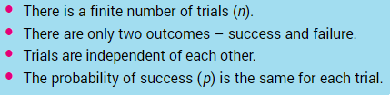

Also: The Binomial Distribution Extended.

- The Normal Distribution:
$Z= \frac{x- μ}{σ}$ Page 34 Tables

